Curriculum Vitae (C.V.)
- Personal data:
Name (Arabic) | ريم صفوت محمد زين
Name (English) | Reem Safwat Mohamed Zein
Department | Medical biochemistry and molecular biology
College | Banha faculty of medicine
Academic degree | Bachelor of medicine and surgery
Office Address
Mobile 1 | 01002100086
Home phone | 0224744144
Work phone
Fax
Email (university) | Reem.safwat@fmed.bu.edu.eg
Email (alternative) | Reemsafwat99@gmail.com
Web site (if any)
Recent Photo (passport format) | 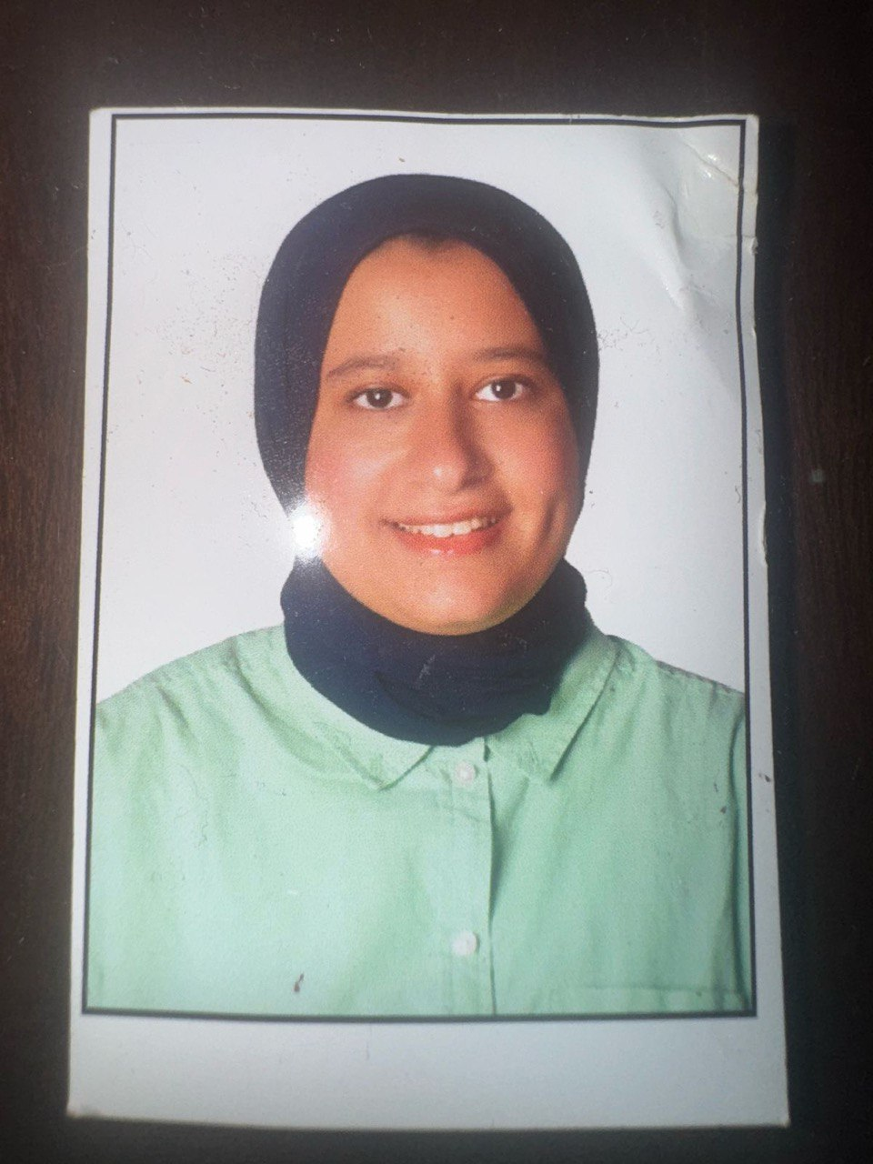
- Education:
2.A. Degree obtained;
Institution | Degree obtained | Year
Banha faculty of medicine | Bachelor of medicine and surgery | 2015
Banha faculty of medicine | Master degree in medical biochemistry | 2021
Banha faculty of medicine | Md in medical biochemistry | 2025 -till now

2.B. Specialty;
General specialty. | Biochemistry
Specific specialty. | Biochemistry

2.C. Language skills (Excellent, Very Good, Good or Basic);
Language | Reading | Speaking | Writing
Arabic. | Excellent | Excellent | Excellent
English. | Excellent | Excellent | Excellent
French.
Germany | Basic | Basic | Basic

- Positions:
Tittle | Year | /Institution
Demonstrator, Department of medical biochemistry | 2018 | Banha University, faculty of medicine
Assistant lecturer, Department of medical biochemistry | 2021 | Banha University, faculty of medicine
Lecturer, Department of medical biochemistry | 2025 | Banha University, faculty of medicine

- Cooperation with local and international entities having website:
( جامعة – مؤسسة - وزارة – مركز بحثي – عضو هيئة تدريس – باحث - شركة – مصنع – الخ)
Name of local and international entity | Website
- Membership of professional bodies (List):

- Membership of institute (List):

- Distinction and Awards (List):

- Academic:
Courses at under graduate level;
1. Course name: | Clinical rounds;
2. Course name: | Lectures;
Courses at post graduate level;
1. Course name: | Clinical rounds;
2. Course name: | Lectures;
- Areas of research:

- PhD/M.Sc Supervision:
Title | PhD/M.Sc | Year completed / in progress

- Grants for Projects:
Funding organization | Project title | Role | Year
- Committees:

- List of Publications:

- Mohamed Zein, R. S. (2025). Circulating MicroRNA-329 as biomarker for breast cancer detection.
Faculty of Medicine, Benha University.
Supervised by N. F. I. Al-Hussein, N. M. A. Emarah, Y. M. A.-R. Marei, & H. E. Nasr.
- Role of Thymosin Beta-4 as an Anti-Ferroptotic Gene in Coronary Atherosclerosis
Authors: Reem Safwat Mohamed Zein¹, Mahasen Abd Elsattar¹, Shuzan Ali Mohammed¹, Mohamed H. Faheem², Yasmin Mohammed Marei¹
¹Medical Biochemistry & Molecular Biology Department, Faculty of Medicine, Benha University ²Radiology Department, Faculty of Medicine, Benha University
14. Attended Workshops, Symposiums, and Conferences: "List name and year";

Name of Workshops, Symposiums, and Conferences | Year
practical training course program real time PCR(absolute and relatuive quantification) – Gene expression | 2022
10th Annual Medical Conference | 2023  Benha University, Biochemistry Department  Presented original research findings to academic and clinical audience Demonstrated expertise in biochemical research communication | 2023
11th Annual Medical Conference | 2023  Benha University, Biochemistry Department  Presented original research findings to academic and clinical audience Demonstrated expertise in biochemical research communication | 2024
Diabesity (the link) | 2025

- Books published:

16. Positions:
 | Date | Organization | Country | Position
1
2
3

17. Activities in faculty/university/community service:
Name of Activity service | Year
- Teaching :(Rounds and lectures). taught practical biochemistry sessions to first- and second-year medical students  - Teaching (Rounds and lectures). taught = biochemistry lectures to first- and second-year medical students | 2018 – 2012  2025
- Clinical meeting.
- Making conferences. | Speaker: 11th Annual Medical Conference | 2024  Benha University, Biochemistry Department  - Presented original research findings to academic and clinical audience Demonstrated expertise in biochemical research communication  Speaker: 12th Annual Medical Conference | 2025  Benha University, Biochemistry Department  - Presented original research findings to academic and clinical audience Demonstrated expertise in biochemical research communication
- Medical Convoys.
- Workshops.
18. Consulting Experience (if any):

19. Additional information you would like to put on the website:

